BENADY CONSULTING · WHITE PAPER · AUGUST 2026
Why AI Can Read Your Budget Impact Model — But Can't Review It
Three gaps in general-purpose AI for health economic models — and the structural approach that closes them
Upload an Excel-based budget impact model (BIM) to a modern chatbot and the results look impressive. GPT and Claude can write Python code, open worksheets, extract values and trace formulas. But executing code against a workbook is not the same as understanding the model behind it. In our benchmarking of general-purpose chatbots against real health economic workbooks, the failures cluster into three gaps — and all three are, at heart, quality-control problems rather than question-answering problems. ISPOR good-practice guidance has long held that evaluating a health economic model means examining its structure, inputs, assumptions and validation, not just its outputs [1,2].

How exactly do LLM chatbots work with Excel sheets?
An .xlsx file is not a grid the model can look at. It is a ZIP archive of OOXML parts — XML files holding sheet contents, shared strings, named ranges and formulas stored as text. No chatbot reads this XML natively. Instead, GPT- and Claude-style systems attach a code interpreter (a sandboxed Python environment) and run a ReAct-style agentic loop [3]: the LLM acts as a planner that alternates between a Thought (deciding the next step), an Action (writing Python code, typically openpyxl or pandas, which parses the XML into cell objects), and an Observation (whatever the code prints to stdout). The loop repeats until the planner decides it has enough to answer. Critically, the model never perceives the workbook itself — only the fragments its own code chooses to print.
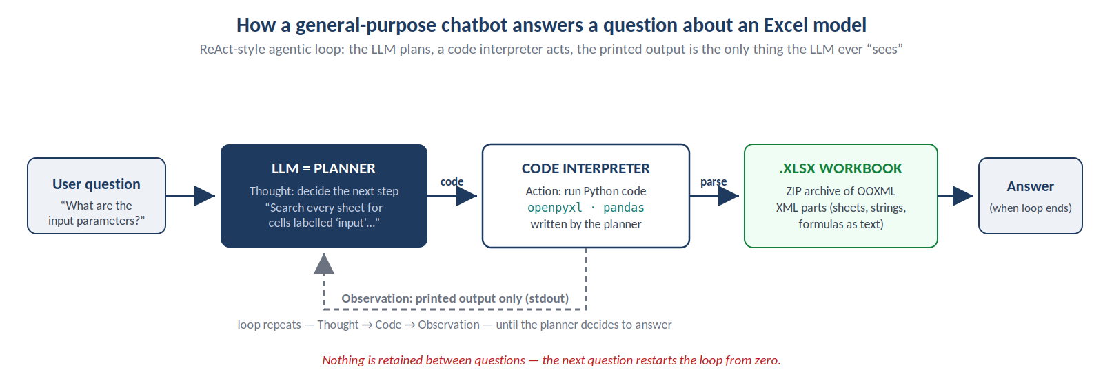
Figure 1. The ReAct loop a general-purpose chatbot runs over an Excel workbook.
A worked example makes the loop concrete. Asked “What are the input parameters of this model?”, the planner's first thought is to scan every sheet for candidate input locations, and it writes code such as:
for ws in wb.worksheets:
for row in ws.iter_rows():
for c in row:
if isinstance(c.value, str) and "input" in c.value.lower():
print(ws.title, c.coordinate, c.value)
The observation comes back as printed hits — say, on sheets named Inputs, Dosing and Engine. The planner's next thought: “read the table inside the Inputs sheet,” producing a second snippet:
df = pd.read_excel("bim_model.xlsx", sheet_name="Inputs",
header=1, usecols="B:E")
print(df.head(20))
After a few such rounds the planner assembles an answer. This loop is genuinely powerful — it is the same pattern behind modern coding agents — but notice what it depends on: the planner's keyword heuristics decide where to look, the printed output decides what the model knows, and nothing built in one loop survives into the next question. Those three dependencies are precisely where the gaps below originate.

Gap 1 — No knowledge of how models are built
A health economist does not find a model's inputs by looking for cells labelled "Input." Real parameters of a BIM model that is not fully complete can sit in calculation sheets, dosing tables, appendices and scenario controls; some cells that look like inputs feed nothing at all. Interpreting a workbook requires reconstructing its computational graph — how epidemiology determines the eligible population, how market shares allocate patients, how dosing drives drug cost, and how these flows produce budget impact. Decades of spreadsheet research reaches the same conclusion: workbooks are dependency structures, and errors concentrate precisely where those dependencies cross sheets and go unexamined [4,5]. Even recent LLM-oriented work on encoding spreadsheets treats the grid as a structured artifact to be parsed, not text to be skimmed [6]. General-purpose chatbots inspect sheets one at a time, so they routinely report unlinked tables as genuine inputs, miss assumptions embedded in formulas, and answer confidently before they have finished reading the model.

Gap 2 — No persistent knowledge graph
In a conventional chatbot workflow, each question can trigger a fresh round of workbook inspection and code generation. The system rediscovers the population logic for one question, reconstructs market shares for the next, and traces costs again for a third — slowly, expensively, and with no guarantee the three answers agree. The established remedy is a knowledge graph: an explicit, persistent representation of entities and their relationships, built once and queried many times [7]. Applied to a health economic model, the graph holds worksheets, tables, cells and formulas; cross-sheet dependencies; recognised parameter types; the epidemiology, market-share and cost pathways; and a citation from every node back to its originating Excel cell. Recent graph-based retrieval work shows why this matters for reasoning: multi-step questions are answered by traversing relationships in a constructed graph, not by re-reading raw source material each time [8]. Retrieval from a validated graph replaces rediscovery — and makes every answer auditable.

Gap 3 — No model archetype
Experienced modellers review a new workbook against an internal archetype — an expected architecture in which eligible population flows to treatment allocation, market shares, treatment-specific patient numbers, resource use and, finally, budget impact. Expert review is fundamentally a comparison: what is present, what is different, what is missing? This mirrors ISPOR's conceptual-modelling guidance, which requires the decision problem to be translated into an explicit expected structure before implementation is judged [2], and formal frameworks now exist for deriving such structures systematically [9]. A general-purpose LLM carries no operational BIM archetype. A domain-specific system should — including jurisdiction-specific variants for Canadian, US and NICE submissions — enabling checks such as whether market shares sum to 100% in every year and scenario, whether patient numbers derive from the correct eligible population, whether every identified input actually feeds the engine, and whether drug costs link to the right dose, frequency and duration. This is the machinery of model verification and validation that ISPOR treats as central to credibility [1].

Closing the gaps: structure first
A fit-for-purpose system should first parse the workbook's computational architecture deterministically — tables, formulas, named ranges, dependencies and cross-sheet flows. Second, it should enrich that structure semantically against a health economics ontology, recognising concepts such as incidence, prevalence, market share, dosing and cost categories. Third, it should compare the resulting model knowledge graph against the appropriate BIM archetype. Only then should an LLM answer questions, explain calculations or run QC. This ordering follows the design lesson of modern coding and spreadsheet agents, whose reliability comes from strong structural representations and validation loops rather than from one-shot prompting [10,11]. It is the architecture we are building in XLGEN: structure-first parsing of Excel health economic models into an ontology-grounded and fully cited knowledge graph.

Related work from Benady Consulting
This white paper accompanies two longer papers. Paper 1 is a systematic review of agentic AI systems for spreadsheets — what coding agents, SheetAgent-style systems and encoding approaches can and cannot do today [https://docs.benadyconsults.com/papers/paper-1-agentic-coding/]. Paper 2 describes the XLGEN architecture in full — structural parsing, knowledge-graph construction, ontology grounding for HTA-grade auditability [https://docs.benadyconsults.com/papers/paper-2-xlgen-whitepaper/]. Both papers, with the underlying technical documentation, are available at docs.benadyconsults.com. XLGEN is a public repo here: https://github.com/behnam-sharif/xlgen

References
1. Eddy DM, Hollingworth W, Caro JJ, et al. Model transparency and validation: a report of the ISPOR-SMDM Modeling Good Research Practices Task Force-7. Value Health. 2012;15(6):843-850.
2. Roberts M, Russell LB, Paltiel AD, et al. Conceptualizing a model: a report of the ISPOR-SMDM Modeling Good Research Practices Task Force-2. Value Health. 2012;15(6):804-811.
3. Yao S, Zhao J, Yu D, et al. ReAct: synergizing reasoning and acting in language models. ICLR 2023. arXiv:2210.03629.
4. Panko RR. What we don't know about spreadsheet errors today. Proc EuSpRIG 2015. arXiv:1602.02601.
5. Hermans F, Pinzger M, van Deursen A. Detecting and visualizing inter-worksheet smells in spreadsheets. Proc ICSE 2012.
6. Dong H, Zhao J, Tian Y, et al. SpreadsheetLLM: encoding spreadsheets for large language models. Proc EMNLP 2024. arXiv:2407.09025.
7. Hogan A, Blomqvist E, Cochez M, et al. Knowledge graphs. ACM Computing Surveys. 2021;54(4):1-37.
8. Edge D, Trinh H, Cheng N, et al. From local to global: a Graph RAG approach to query-focused summarization. arXiv:2404.16130. 2024.
9. Squires H, Chilcott J, Akehurst R, Burr J, Kelly MP. A framework for developing the structure of public health economic models. Value Health. 2016;19(5):588-601.
10. Yang J, Jimenez CE, Wettig A, et al. SWE-agent: agent-computer interfaces enable automated software engineering. NeurIPS 2024.
11. Chen Y, et al. SheetAgent: towards a generalist agent for spreadsheet reasoning and manipulation via large language models. Proc WWW 2025. arXiv:2403.03636.
Benady Consulting · AI for health economic models · docs.benadyconsults.com

